The Red Tea Detox Affiliate Emails
This document contains 7 highly profitable email swipes you can use in your promotions of The Red Tea Detox.

They have been tested repeatedly and tweaked and fine-tuned for the best conversions possible.

Be sure to insert your links at the appropriate locations within the email swipes.

Your hoplink format is as follows:

http://XXXXX.redteax.hop.clickbank.net

Just replace “XXXXX” with your Clickbank affiliate ID.
We wish you all the best in your promotions of The Red Tea Detox.

Signed with success,

The Red Tea Detox Team

Email 1
Subject:
Soothing Red Tea Latte :-)
Send to un-opens : Calming red tea latte?
Email:
There’s nothing better than finishing your day with a sweet and soothing red tea latte that’ll keep your metabolism burning all night long, right? So…
Try out this delectable red tea latte tonight and let me know what you think...
=> Evening Red Tea Latte (Tastes Like Heaven)

Email 2
Subject:
Belly Fat Frying Iced Tea
Send to Un-opens: Belly Flattening Iced Tea
Email:
It’s another scorcher out there...
The most refreshing way to cool down is a tall glass of thirst-quenching iced tea...
And if you want to help shed those extra pounds quicker than ever, there’s nothing quite like this iced tea recipe.
It’s without a doubt the BEST iced tea to both get you ready for bathing-suit season AND give you a delicious way to cool down.
Have a taste...
=> Belly Fat Frying Iced Tea
Enjoy!

Email 3
Subject:
Sunrise Fat-Shredding Tea
Email:
Nothing’s better than starting your day with a hot cup of delicious tea that energizes more than coffee can and kicks your metabolism into high gear…
So try out this invigorating fat-burning tea first thing in the morning and give me your thoughts...
=> Sunrise Fat Shredding Tea
Enjoy!

Email 4
Subject:
African Voodoo Tea
Send to Un-opens 1: My Go-To Tea :-)
Send to Un-opens 2: Are You A Fan of Tea {!firstname_fix}?
Email:
Today, I’ve got a delicious red tea found deep in the heart of Africa and an unforgettable story of how it helped one lucky woman melt 41 pounds of body fat...
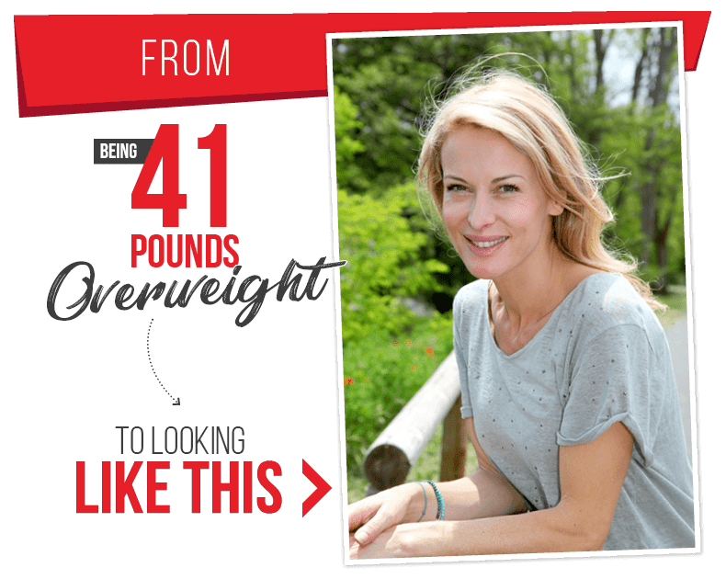
<a href="http://XXXXX.redteax.hop.clickbank.net/"><img src="http://www.redteadetox.com/images/email-before-after.png" alt="The Red Tea Detox"></a> (PLACE CODE HERE TO SHOW THE IMAGE) OR JUST DOWNLOAD THE IMAGE AND PLACE MANUALLY)
It’s pretty unbelievable at first, but once you hear all about this red tea made by African shamans, it’ll all start to make sense.
So try out this tasty tea and let me know what you think...
=> Energizing and Scrumptious Tea Can MELT the Pounds Off!
Stay healthy!
Email 5
Subject:
Shed 40+Lbs drinking tea...
Send to Un-opens: Liz [PIC]
Email:
What would you say if I told you that there’s a tea hidden deep in the remote wilds of Africa, that one small-town woman from Alabama uncovered, that can promote intense metabolism boosts and can eliminate even the most persistent fat?
And beyond that, it’ll also practically eliminate any food cravings throughout the entire day while still keeping you energized from sunrise to sunset.
Take a look at Liz’s astounding transformation below. After a difficult pregnancy, she shed more than 40 pounds in just a few weeks, all by drinking this rare and exotic tea, shocking her husband and all of her friends…
<a href="http://XXXXX.redteax.hop.clickbank.net/"><img src="http://www.redteadetox.com/images/email-before-after.png" alt="The Red Tea Detox"></a> (PLACE CODE HERE TO SHOW THE IMAGE) OR JUST DOWNLOAD THE IMAGE AND PLACE MANUALLY)
Actually, Liz was so embarrassed of her body before she lost all this weight that she used to get ready for bed in the dark, just so her husband wouldn’t be able to see all the extra pounds she’d put on. That is until…
She heard stories about an unbelievable tea crafted by African shamans that powerfully and naturally detoxifies your body, clears out your organic fat-burning zones of harmful toxins and other destructive elements (free radicals, heavy metals) that are keeping you sick, fat, and sluggish, and even revitalizes your body’s natural weight loss abilities, permanently!
It’s a truly astounding tale, and you can discover the whole thing by clicking here…
=> Uncover the exotic “red drink” that let Liz lose over 40 pounds in just weeks
Stay healthy!

Email 6
Subject:
The BEST Tea (It's not green)
Send to un-opens: Healthiest Tea (It's not green)
Email:
Have you heard about how everyone thinks green tea is the healthiest kind of tea you can drink? Well…
What would you say if I told you that actually a special RED tea is a lot better for your body and it can even help clear your body of toxins and shed a lot of extra pounds? And…
Green tea can actually be tough on the stomach and might cause nausea, constipation, and even liver damage! So…
=> These Are Just Some Reasons for AVOIDING Green Tea And Drinking Red Instead!
Prepare to be shocked!

Email 7
Subject:
"Red" Tea Helps Alabama Girl Drop 41 lbs!
Send to Un-opens: This rare RED Tea helped Alabama girl drop 41 lbs
Email:
We all know that green tea is great for the body, right? Well…
Have you ever heard of “red” tea? No? You need to have a look at this story…

<a href="http://XXXXX.redteax.hop.clickbank.net/"><img src="http://www.redteadetox.com/images/email-before-after.png" alt="The Red Tea Detox"></a> (PLACE CODE HERE TO SHOW THE IMAGE) OR JUST DOWNLOAD THE IMAGE AND PLACE MANUALLY)

=> “Red” Tea Helps Alabama Girl Drop 41 lbs!

Stay healthy!

